Lab 2: Containerization & Kubernetes Orchestration
Task 7: Docker Network

1. Objective
Show communication between two containers over a Docker network using the container name and the container IP address.

2. Create network and containers
docker network create lab2-net
docker run -d --name lab2-net-app --network lab2-net lab2-python-app:1.0
docker run -d --name lab2-net-client --network lab2-net curlimages/curl sleep 3600

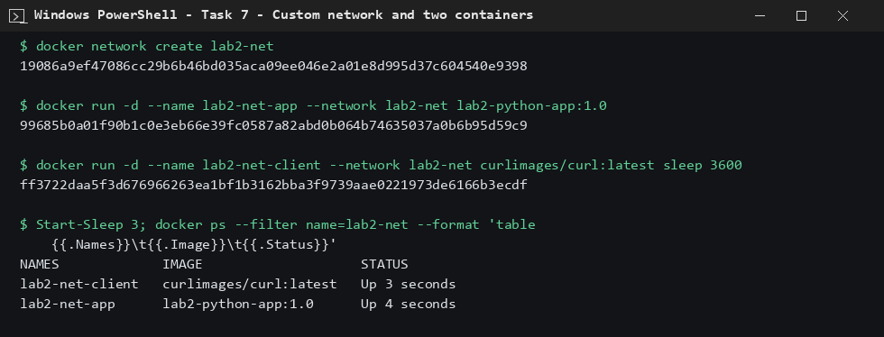
Figure 1: Network created and both containers running

3. Communication by name and by IP
A user-defined network has built-in DNS, so the client reached the app by name. The app's IP (172.20.0.2) also worked.
docker exec lab2-net-client curl -s http://lab2-net-app:5000/health
docker exec lab2-net-client curl -s http://172.20.0.2:5000/health
docker network inspect lab2-net

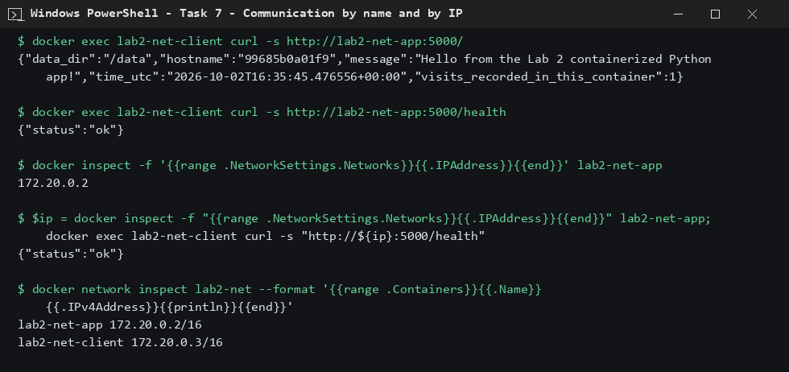
Figure 2: Requests by container name and by IP both succeed

4. Conclusion
Containers on the same custom bridge network communicate using either container names (Docker DNS) or IP addresses.

